PSPRadio

A User’s Guide

(Compatible with Release 0.37 Final)

Compiled by albadross (David Dew)

Version 2.0 |  | 14 January 2006

PROGRAM OPERATION

There are 4 main screens available to you in this program. The first 3 are playback screens and are -:

- The Main Playlist playback screen

- The Shoutcast playback screen

- The Local Files playback screen

There is also a fourth screen, the Options screen, that allows you to set your preferences and to exit the program smoothly.

The following pages give details of how these screens operate.

THE MAIN PLAYLIST PLAYBACK SCREEN

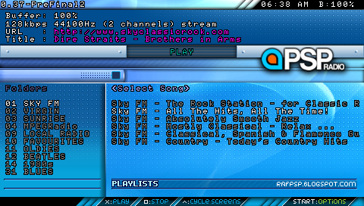

You may choose to set up your own playlists (based on the Winamp v1 or v2) format.

Any playlists you set up should be placed in the /Playlists folder and they will appear on this screen.

If you do not wish to set up your own playlists, you can go straight to the Shoutcast Screen by pressing the Triangle button.

When you first reach the Main Playlist playback screen, you have control of the left-hand (Folders/Playlists) column.

You can move up and down this column with the keypad.

When you have got to the playlist you require, press Circle or Cross to move control to the right-hand (Song Selection/Station) column.

(For the purposes of PSPRadio, the Circle and Cross buttons perform the same function.)

You can then move up and down the entries with the keypad.

When you have got to the station or music track you require, press Circle or Cross to start playing it.

You should start hearing music as the buffer approaches 100%.

Pressing the Square button stops the playback.

Pressing the Left button on the keypad returns control to the left-hand column.

Pressing the Start button takes you to the Options Screen.

THE SHOUTCAST PLAYBACK SCREEN

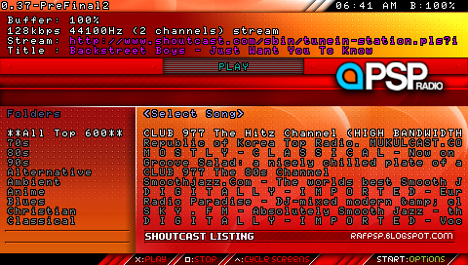

This screen gives you access to the Top 600 Shoutcast Radio stations at any one time. It is also sorted so that you can select by genre of music.

When you first reach this screen, you have control of the left-hand (Folders/Genres) column.

You can move up and down this column with the keypad.

When you have got to the Shoutcast genre you require, press Circle or Cross to move control to the right-hand (Song Selection/Station) column.

(For the purposes of PSPRadio, the Circle and Cross buttons perform the same function.)

You can then move up and down the stations with the keypad.

When you have got to the Shoutcast station you require, press Circle or Cross to start playing it.

You should start hearing music as the buffer approaches 100%.

Pressing the Square button stops the playback.

Pressing the Left button on the keypad returns control to the left-hand column.

Pressing the Triangle button takes you to the Local Files playback screen.

Pressing the Start button takes you to the Options Screen.

THE LOCAL FILES PLAYBACK SCREEN

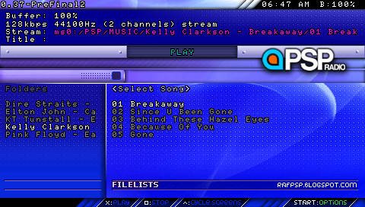

At the start of PSPRadio, the program automatically searches your /PSP/MUSIC/ folder for any sub-folders containing MP3 or OGG tracks. Any such sub-folders are presented to you as folders/albums on the Local Files Playback screen..

The album name comes from the sub-folder name and is used in the Folders column. The individual tracks are presented as entries in the Song Selection column.

When you first reach this screen, you have control of the left-hand (Folder) column.

You can move up and down this column with the keypad.

When you have got to the album/sub-folder you require, press Circle or Cross to move control to the right-hand (Song Selection) column.

(For the purposes of PSPRadio, the Circle and Cross buttons perform the same function.)

You can then move up and down the tracks with the keypad.

When you have got to the track you require, press Circle or Cross to start playing it.

You should start hearing music as the buffer approaches 100%.

In normal operation, the album should automatically load the next track when one track finishes.

When the whole album completes, playback will continue from the beginning again.

Pressing the Square button stops the playback.

Pressing the Left button on the keypad returns control to the left-hand column.

Pressing the Triangle button takes you to the Main Playlist playback screen.

Pressing the Start button takes you to the Options Screen.
THE OPTIONS SCREEN

Pressing the Start button leads you to the Options Screen.

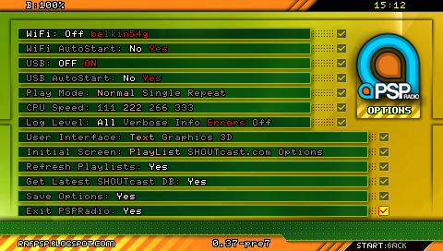

WiFi | This allows you to switch between connections at run-time. (Firmware 1.5 only)
WiFi Autostart | This tells the program whether or not to use your first connection automatically.
USB | This allows you to put the PSP into USB Connection mode at run-time.
USB Autostart | This tells the program whether or not to automatically put the program into USB connection mode.
Play Mode | Refers to the playback of your MP3s ; the choice is between sequentially, one a time, or the same track repeatedly.
CPU Speed | This is obvious but I have found no need to change it from the standard 222 mHz.
Log Level | This details the level of messages provided in the log file by the program. This ranges from  All – Far too much and definitely slows the program down, through to  Errors – The most sensible and useful if something goes wrong  None – If you are a minimalist (and nothing ever goes wrong!)
User Interface | This offers you a choice of interfaces. They are there for you to try (although there is currently a problem with the Options screen on the Graphical interface on the more recent beta versions).
Initial Screen | This specifies which screen will be offered to you when you start the program. Once in the program, pressing Triangle will cycle you round the three main playback screens; pressing Start will take you to the Options screen.
Refresh Playlists | This allows you to update any playlists at run-time that you may have updated in USB Connection mode. At the moment, this does not extend to searching again for any new MP3s you have loaded.
Get Latest Shoutcast DB | This lets you update the Shoutcast database held within the program to the latest Top 600 Shoutcast radio stations on the internet.
Save Options | This lets you save the preferences you have chosen on this screen.
Exit PSPRadio | By far the easiest way to exit the program (without crashing!)

Pressing the Start Button again returns you to the main playback screens.

SCREENSHOTS

There is a facility to take screenshots in the later beta releases of the program.

Pressing and holding the Select button for a few seconds will put a sequentially numbered .png file in the Screenshots folder.

The screenshots can then be manipulated in all the usual programs such as MS Paint, Photoshop, etc.

SKINS

If you do not like the standard skin, there are a few other text interface skins available on the PSPRadio forum that you can try.

It is simply a case of overwriting the following files in the TextUI folder of the PSPRadio program -:

- PlayListScreen.png
- SHOUTcastScreen.png
- LocalFilesScreen.png
- OptionsScreen.png

You may find they give a different feel to the program.

But bear in mind that the buttons you have to press are exactly the same as for the standard skin.

Examples of other skins in actions

- Selector – Local Files playback screen

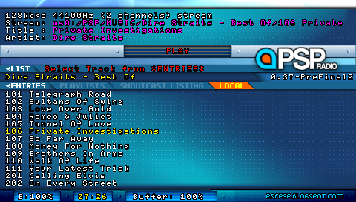

- Stageshow – Shoutcast playback screen

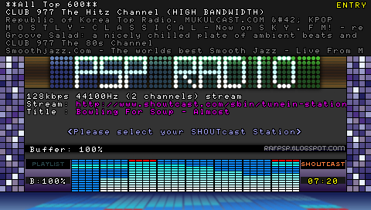

- Metalle – Main Playlist playback screen

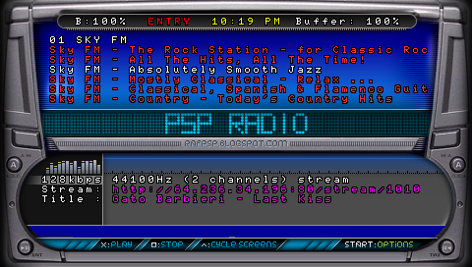

You can always try to make your own!

